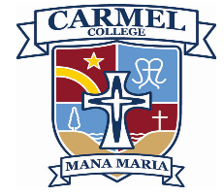
SCHOOL ACTIVITY/ SPORTS LEAVE FORM 2026
(for Years 11-13)
Process:
- This form is for girls who will be away from school due to representing Carmel in an activities or sports eg Tournament week, North Island championship events etc.
Everything else is classed as self interest holidays/ activities not school related(eg sports for clubs), then please complete the self interest/ rep leave form (which requires parents to complete an application online through School Bridge).
- Students print this form to take around to teachers to inform them of the leave period and to determine if it will still be possible to complete assessments that are due during the leave period.
- students hand in completed form to AOF (drop to Mrs O’Farrell office)

Name:
Year level: |  | Atawhai:
Leave dates: | From: to:
Reason for leave:

Please complete the chart for each subject. Please be aware that alternative arrangements may not be possible, and you may need to withdraw from the Achievement Standard.

Subject | Assessments during leave period ? (Y or N)  (state date due + AS number) | Departmental arrangements/ decisions regarding assessments due during the leave period or impacted by the leave. | Teacher’s signature + initials  (following discussion with HOD)

Signed: _______________________________ Date:__________ (student)

Signed: _______________________________ Date:__________ (Mr Atkinson - DP)

