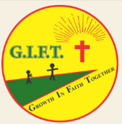
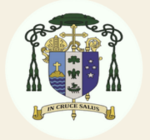
G.I.F.T.
Growth In Faith Together
Ministry for people with intellectual disabilities
Roman Catholic Diocese of Auckland
TE TAUMATA O TE HĀHI KATORIKA
2026 Programme

February 1st Sunday Picnic at Monte Cecilia Park at 12.00
March 7th March 21st

April 4th Easter Saturday April 18th

May 2nd * May 9th Note the change of date

May 30th PENTECOST MASS

June 6th June 20th

July 4th July 18th

August 1st August 15th

August 29th SAINTS and ANGELS DINNER DISCO
6pm - 9pm
September 5th September 19th

October 3rd October 17th

October 31st RETREAT

November 7th November 21st

December 5th

December 6th CHRISTMAS MASS
4pm Good Shepherd Church

Time - 1.00pm to 4.00pm

Where - G.I.F.T. Room in the Pompallier Centre, 30 New St, Ponsonby

Every Saturday programme involves sharing our week’s journey in a safe environment, prayer, singing, Bible reading, discussion, growing in faith, supporting one another, respecting the values of Te Tiriti o Waitangi - behaving with tika, pono and aroha, Te reo Māori, waiata, learning, personal growth and self-determination, and cooking.
Life skills:
- showing manaakitanga: kindness, honesty, respect
- empowering everyone to know that God made each of us unique and special and we all have a place in God’s creation story
- encouraging everyone to understand that G.I.F.T. is their turangawaewae where there is no comparison or judgement
- coping with anxiety, disregulation - acknowledging problems, finding solutions and moving forward
- respecting and learning about different cultures and their festivals
- discussing and praying for local and world current events
- cooking, collaborating, cooperating, creating
- growing in our relationship with Jesus, our best friend

Afternoon tea - about 3.30pm
- please bring something to share

All people with intellectual disabilities most welcome 😍
You are most welcome to come with your whānau, family, friends, support workers and caregivers. 😍

Contact - Vivienne 021 044 8362
viviennea@cda.org.nz

Please join us to
Grow In Faith Together

